Project Report
Name : Thomas Fleming
Course: PROG-2204
Project : HW1-LIDA

Problem Statement
We were the task of implementing ArrayList in C++, with merging functionality, Intersection and Union. Intersection keeps all duplicates whilst Union does not. Due to the provided main function, there was no need to error check as there was only one possible input at any time.
My Design and Development Process
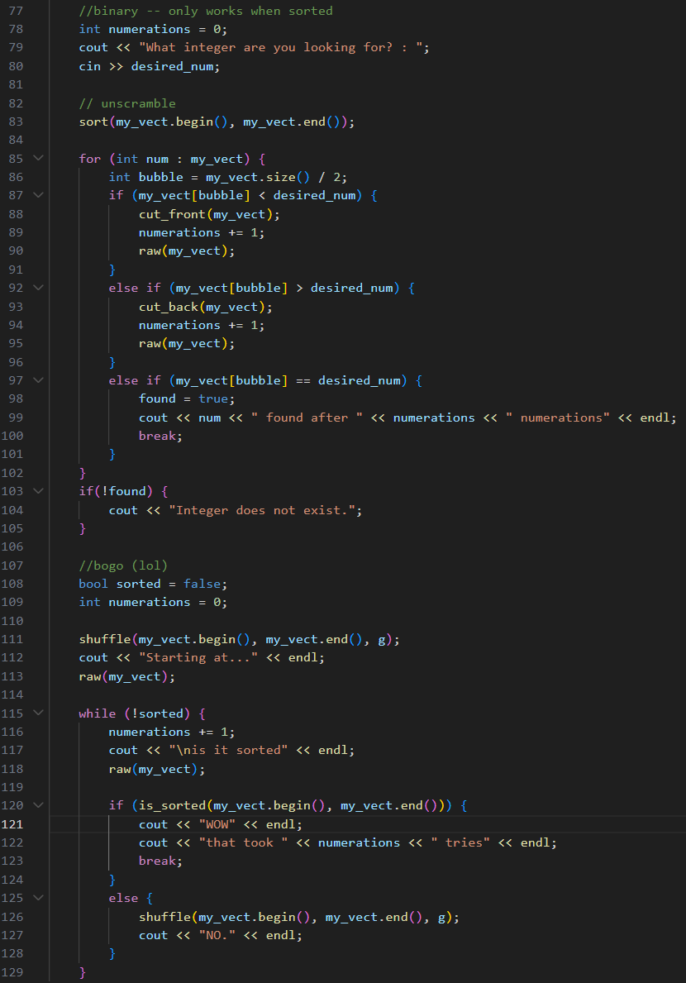
My personal experience with the project was mostly centered around being background support. I’ve come to understand that my code doesn’t hold a candle to the others’, so I participated in pseudocode and brainstorming, but dedicated most of my programming time to understanding sorting and searching algorithms within my own file. (This file is not present in the submission; this is my own file)

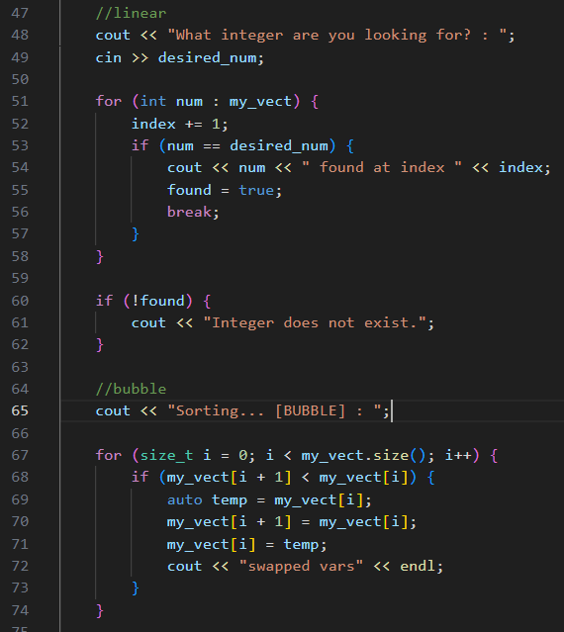

How I Tested My Solution
Testing of the main function was mostly handled by the others. However, during the implementation of Union Sorted, we came across an issue where our two input lists would lose their sortedness upon being merged, as one would just extend off the other. ([…, 18, 19, 20, 1, 2, 3, …]) So, our first idea was to simply re-sort the data using Bubble Sort.
This is where my code came in handy. Zach was unfamiliar with the logic behind Bubble Sort, but was able to make my snippet compatible with the main, and for a time being it was the solution.
We eventually came up with a more elegant solution—making our ArrayList compatible with the standard library’s sort function.

How It Turned Out
Everything turned out as expected in the end. My main difficulty is figuring out how to contribute meaningfully. I’m a very different kind of programmer than the others, and my inexperienced, somewhat brute-force C++ code will inevitably get refactored into something more polished by the team if I write any. And I’d rather provide a pseudo code that they can write themselves rather than my own attempt that they’d have to understand and refactor. This assignment being an exception, where I was moreso providing the logic than the code.

